Pupil premium strategy statement

‘In Jesus' footsteps we will grow in grace and knowledge’
At St Leonard’s, children will understand that God’s grace is the gift given freely out of unconditional love and that all are precious. By following in Jesus’ footsteps, with Pupil Promises at the heart of everything we do, we are shaping confident, thoughtful, courageous advocates of the future and growing God’s kingdom on Earth.
By following Christ’s example we “Grow in the grace and knowledge of our Lord and Saviour, Jesus Christ.” 2 Peter 3:18
Our school vision is reflected in this statement through careful consideration of how the funds are spent, therefore enabling all to flourish, especially our disadvantaged pupils. This statement details our school’s use of pupil premium for the 2024 to 2025 academic year funding. It outlines our pupil premium strategy, how we intend to spend the funding in this academic year and the effect that last year’s spending of pupil premium had within our school.

School overview
Detail | Data
School name | Langho & Billington St Leonard’s CE (VA) Primary School
Number of pupils in school | 306 (4-11)
Proportion (%) of pupil premium eligible pupils | 8%
Academic year/years that our current pupil premium strategy plan covers (3 year plans are recommended) | 2024-2025  2025-2026  2026-2027
Date this statement was published | September 2024
Date of most recent review | September 2024
Date on which it will be next reviewed | September 2025
Statement authorised by | Mrs Dawn Lindley, Headteacher
Pupil premium lead | Mrs Dawn Lindley, Headteacher
Governor / Trustee lead | Mrs Mari Cheeseman

Funding overview
Detail | Amount
Pupil premium funding allocation this academic year | £ 30070
Recovery premium funding allocation this academic year | £ 0
Pupil premium funding carried forward from previous years (enter £0 if not applicable) | £ 0
Total budget for this academic year  If your school is an academy in a trust that pools this funding, state the amount available to your school this academic year | £ 30070

Part A: Pupil premium strategy plan

Statement of intent When making decisions about using Pupil Premium funding it is important to consider the context of our school and the subsequent challenges faced. Research conducted by EEF should is used to support decisions around the usefulness of different strategies and their value for money.

Common barriers to learning for disadvantaged children, can be less support at home, weak language and communication skills, lack of confidence, more frequent behaviour difficulties and attendance and punctuality issues. There may also be complex family situations that prevent children from flourishing.
The challenges are varied and there is no “one size fits all”. We consider fully the needs of Langho St Leonard’s CE School pupils in our decision-making.
Our ultimate objectives are:
To narrow any attainment gap between disadvantaged and non-disadvantaged pupils.
For all disadvantaged pupils in school to make or exceed nationally expected progress rates.
To support our children’s health and wellbeing to enable them to access learning at an appropriate level.

We aim to achieve these through:
Ensuring that teaching and learning opportunities meet the needs of all the pupils and that the quality of teaching experienced by all children is developed and improved.
Ensuring that appropriate provision is made for pupils who belong to vulnerable groups, this includes ensuring that the needs of socially disadvantaged pupils are adequately assessed and addressed
Recognising that not all pupils who receive free school meals are socially disadvantaged
Recognising that not all pupils who are socially disadvantaged are registered or qualify for free school meals.
We use our knowledge of pupils and families to identify pupils we consider need extra support including classes, groups or individuals.
To encourage parents/ carers to apply for free school meals where pride, stigma or changing circumstances may act as a barrier
Providing small group work focussed on overcoming gaps in learning and running nurture groups.
Ensuring that all teaching assistants are deployed and used effectively to support children according to identified need
Supporting/subsidising payment for activities, educational visits and experiences.
Ensuring children have first-hand experiences to use in their learning in the classroom.
Aiming at accelerating progress, particularly the most able disadvantaged at least in line with non-disadvantaged peers.

Challenges
This details the key challenges to achievement that we have identified among our disadvantaged pupils.
Challenge number | Detail of challenge
1 | Pupil wellbeing, and social, emotional health for pupils, including those eligible for PP is still negatively affected as a result of the Covid pandemic legacy.
2 | The resilience of some families is still suffering due to covid legacy, and although higher than national average, overall attendance remains lower than pre covid times.
3 | Some disadvantaged children make slower rates of progress than non-disadvantaged as they move through school.
4 | A proportion of our disadvantaged children have identified SEND barriers to learning.
5 | Fewer disadvantaged children are working at greater depth in reading, writing and maths compared to non-disadvantaged children.

Intended outcomes
This explains the outcomes we are aiming for by the end of our current strategy plan, and how we will measure whether they have been achieved.
The best way to ensure all children, including disadvantaged children, make the best progress is to ensure they receive quality first teaching.
Intended outcome | Success criteria
To increase KS1 and KS2 attainment in reading, writing and maths combined at the expected and greater depth level. | Quality first teaching ensures high rates of progress and end of KS outcomes to remain on an upward trajectory with combined outcomes at expected and greater depth, improving.
The progress and attainment of disadvantaged children to be at least in line with non- disadvantaged children. | Children in receipt of Pupil Premium are carefully monitored and supported to achieve expected and higher levels of progress and attainment.  Timetabling is effective and TAs deployed strategically to support individual and identified needs. Training in place to enable effective provision.
Ensure high levels of pupil wellbeing, social and emotional health and safety of all children to enable them to flourish. | Focus on social and emotional learning across school has raised awareness of everyone’s well being. Children are equipped with strategies and can effectively identify and self regulate emotions.
Pupils’ personal development and achievement in wider curriculum subjects is in line with non PP pupils and cultural capital is developed and sustained. | Children in receipt of Pupil Premium have access to all wider opportunities and encouraged to take part. Families facing challenging circumstances are actively engaged.  Experiences and visits are planned for children across the year,and children have access to a wide range of extra-curricular clubs. Pupil voice shows a greater understanding of the world around them.
Attendance to return to highest levels pre-pandemic and that all children in receipt of Pupil Premium are in-line with their peers. | Careful monitoring and actions ensures that attendance levels remain very high across school. Children in receipt of Pupil Premium and their families, are supported to maintain high attendance levels in-line with their peers.

Activity in this academic year (2024-25)
This details how we intend to spend our pupil premium (and recovery premium funding) this academic year to address the challenges listed above.

Teaching (for example, CPD, recruitment and retention)

Budgeted cost: £17,000

Activity | Evidence that supports this approach | Challenge number(s) addressed
To review our approach to providing effective feedback as part of quality first teaching.  Feedback policy to be refined.  Staff CPD - effective feedback | ‘Feedback is one of the most powerful influences on learning and achievement’ John Hattie  Our approach to effective feedback takes into account the summary of recommendations from the EEF  https://educationendowmentfoundation.org.uk/education-evidence/teaching-learning-toolkit/feedback | 3, 4, 5
Purchase of  standardised diagnostic assessments  (NTS) .  Training for staff to ensure assessments are administered correctly and information utilised through question level analysis. | Standardised tests can provide reliable insights into the specific strengths and weaknesses of each pupil to help ensure they receive the correct additional support through interventions or teacher instruction:  Standardised tests | Assessing and Monitoring  Pupil Progress | Education Endowment  Foundation | EEF | 3, 4, 5
‘Little Wandle’  Subscription DfE validated Systematic  Synthetic Phonics programme  Home Reading Books to be purchased for Y2 – Y6.  Reading Plus subscription to be purchased and timetabled use. | Phonics approaches have a strong evidence base that indicates a positive impact on the accuracy of word reading (though not necessarily comprehension), particularly for disadvantaged pupils:  Phonics | Toolkit Strand | Education  Endowment Foundation | EEF | 3, 4, 5

Enhancement of our maths teaching and curriculum planning in line with DfE and EEF guidance. | The DfE non-statutory guidance has been produced in conjunction with the National Centre for Excellence in the Teaching of Mathematics, drawing on evidence-based approaches:  Maths_guidance_KS_1_and_2.pdf (publishing.service.gov.uk)  The EEF guidance is based on a range of the best available evidence:  Improving Mathematics in Key Stages 2 and 3 | 3, 5
Deployment of teachers without full class responsibility, to teach Maths across KS1 & LKS2 Phase, and Phonics across KS1.  Teaching  Assistant to be deployed  strategically according to the needs of the children. | EEF “As the size of a class or teaching group gets smaller it is suggested that the range of approaches a teacher can employ and the amount of attention each student will receive will increase, improving outcomes for pupils.”  This approach allows us to increase the amount of attention each child will receive and enables Maths to be taught in straight year groups rather than mixed classes.  Allocation of TAs ensures that and that Little Wandle early reading is fully facilitated. | 1, 3, 4, 5
 |  | 1, 3, 4, 5
Teaching and learning CPD  for all staff in school – to create highly effective practitioners in all classrooms. Fully planned approach to CPD utilises school improvement partner and high quality trainers. | EEF guide to pupil premium – tiered approach – teaching is the top priority, including CPD.  “Good teaching is the most important lever schools have to improve outcomes for disadvantaged pupils. Using the Pupil Premium to improve teaching quality benefits all students and has a particularly positive effect on children eligible for the Pupil Premium.”
Review of handwriting policy and focus on improvement across school  Grammarsaurus subscription and refinement of our approach to the effective teaching and assessment of writing. | The aim of handwriting practice is to support children to develop a quick, efficient, and legible handwriting style. Slow or effortful transcription hinders writing composition as pupils have to concentrate on monitoring their handwriting and are less able to think about the content of their writing. EEF ‘Improving Literacy In KS2’.  The EEF guidance report, ‘Teacher Feedback to Improve Pupil Learning’, provides six recommendations on how teachers can give pupils effective feedback across different subjects and key stages. The recommendations are summarised below with examples of how they could be applied to the teaching of transcription and sentence construction. | 3, 4, 5

Targeted academic support (for example, tutoring, one-to-one support structured interventions)

Budgeted cost: £10, 000

Activity | Evidence that supports this approach | Challenge number(s) addressed
Teachers identify individuals & small groups including PP children for additional support following identified areas of need from assessment. These are delivered either by the teacher or additional TA. | EEF (+4)  “Small group tuition is defined as one teacher or professional educator working with two to five pupils together in a group. This arrangement enables the teacher or TA to focus exclusively on a small number of learners, usually in a separate classroom or working area. Intensive tuition in small groups is often provided to support lower attaining learners or those who are falling behind, but it can also be used as a more general strategy to ensure effective progress, or to teach challenging topics or skills.”  Accelerated progress for children in receipt of interventions and other targeted support. Teachers will be working with intervention groups to address gaps. | 1, 2, 3, 4
Toe by Toe multi sensory reading programme delivered by trained TA providing regular and frequent 1:1 sessions for identified KS2 children requiring rapid progress with the mechanics of reading. | https://educationendowmentfoundation.org.uk/education-evidence/teaching-learning-toolkit/one-to-one-tuition  'On average, one to one tuition is very effective at improving pupil outcomes. One to one tuition might be an effective strategy for providing targeted support for pupils that are identified as having low prior attainment or are struggling in particular areas.' | 2, 3, 4

Wider strategies (for example, related to attendance, behaviour, wellbeing)

Budgeted cost: £10,000

Activity | Evidence that supports this approach | Challenge number(s) addressed
‘Seeds of Happiness’ subscription and implementation to develop children’s emotional wellbeing.  To refine the behaviour policy enhancing our relational approach. Purchase ‘When the adults change’ behaviour CPD  Virtual school Attachment and Trauma CPD to further improve staff knowledge and understanding of the impact of ACEs | There is extensive evidence associating childhood social and emotional skills with improved outcomes at school and in later life (e.g., improved academic performance, attitudes, behaviour and relationships with peers):  EEF_Social_and_Emotional_Learning.pdf(educationendowmentfoundation.org.uk) | 1, 3, 4
Consistent approach to the teaching of emotional language and self regulation strategies across school.  Staff training – Forest School qualification  The Dog Mentor (school dog) to work across school with identified children to improve emotional wellbeing and aid learning. | Targeted nurture support from behaviour lead and TAs for identified children.  Woodland ‘Forest schools’ learning to be offered to all children across school.  The above having a positive impact on attendance, behaviour and well being.  https://www.cypnow.co.uk/features/article/specialreport-research-outdoor-learning-researchevidence-study-1  https://files.eric.ed.gov/fulltext/EJ1173578.pdf Research review Are therapy dogs in classrooms beneficial?  Findings included...  -Contributed to students' overall emotional stability  -Improved students' attitudes toward schools  -Facilitated students learning lessons in responsibility,  respect, and empathy  Students' attitudes toward school improved.  -Students found companionship with the dog.  -Students used the dog to remain in control of their  emotions and behaviors in order to prevent them from  entering emotional crisis.  -Students used the dog as a de-escalation tool to calm  their minds and bodies when they did enter into  emotional crisis.  -Students' learning was extended by fostering growth in  respect, responsibility, and empathy. | 1, 2
Subsidised visits/ visitors, experiences and extra curricular activities for PP children.  Additional food hygiene, food preparation and cookery lessons Years 3 & 4 | ‘Poverty has a significant impact on the educational experience and attainment of many children growing up in the UK’ NEU  PP pupils do not have access to as many activities which promote cultural capital. Financial support can be provided to ensure children in receipt of PP are able to take part.  Areas where PP pupils are supported: Residential visits where financial support may be offered to cover some costs. Visits out of school.  Uniform costs for PP children where needed.  After school club costs for PP children where needed | 1,
Attendance given high priority.  Robust monitoring of attendance data and subsequent actions.  Pastoral and behaviour lead to support identified families. | Dfe Working together to improve school attendance.  https://assets.publishing.service.gov.uk/media/63049617e90e0729e63d3953/Working_together_to_improve_school_attendance.pdf | 1, 2

Part B: Review of outcomes in the previous academic year

Pupil premium strategy outcomes
This details the impact that our pupil premium activity had on pupils in the 2023-24 academic year.

Our work within 2023-24 has led to improving academic outcomes across school.

EYFS children made substantial progress in all areas.
GLD increased from 87% (2022) 91% (2023) 93% (2024)
Year 1 Phonics increased from 87% (2022), 94% (2023), 100% (2024) End of KS1 data (2024) is above national figures and on an upward trajectory, improving on 2022 and 2023 outcomes.
Year 4 Multiplication Test 2024
School average score = 21.1/25 (Pupil Premium average score 21.8) and 38% achieved full marks
For comparison: National Average 2023 = 20.2 /25 (2023 Pupil Premium average score 18/25) and 29% achieved full marks nationally (2023)

End of KS2 results 2023 (Disadvantaged):
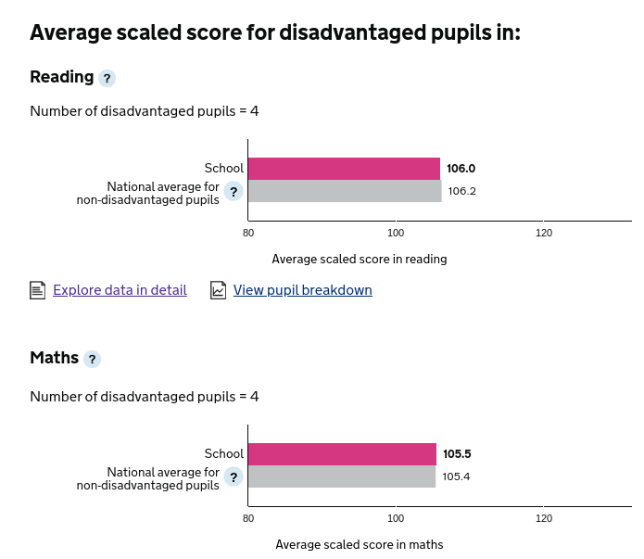
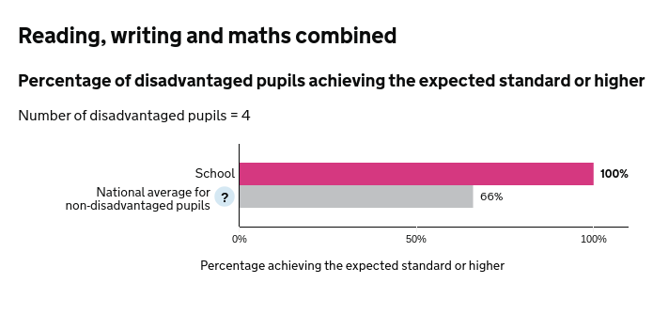

Progress (2023 Disadvantaged)
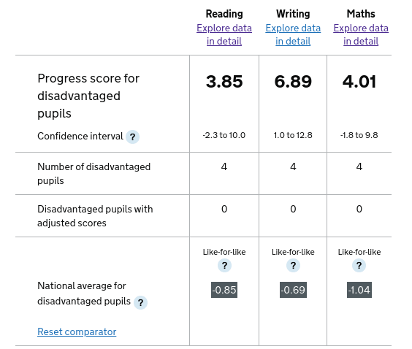

End of KS2 2024

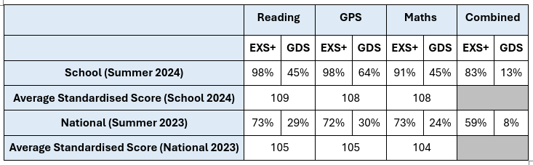

Wider Strategies
Support staff deployment and intervention for identified individuals has had a positive impact upon learning. Educational visits and enhancement opportunities have supported children’s wider development. Individual emotional support provided to children in the form of nurture, has had a positive effect across school.
SIAMS inspection March 2023 -
‘The school's Christian vision for all to follow in Jesus' footsteps is implicitly woven into all
aspects of school life. It inspires decision making by leaders, creating a nurturing community
where pupils and adults flourish.
Inspired by the Christian vision, there is a strong commitment to pastoral care. The mental
health and wellbeing of pupils and adults is given the highest priority.’

Externally provided programmes
Please include the names of any non-DfE programmes that you purchased in the previous academic year. This will help the Department for Education identify which ones are popular in England
Programme | Provider
Reading Plus | Reading Solutions
Little Wandle
Kapow
Learning By Questions
Toe By Toe
Pathways to Write | The Literacy Company

