St Leonard’s Church of England
Primary School

Forest School Policy
(To be read in conjunction with the
Forest School Handbook)

Date written: | September 2025
Policy written by: | Debbie Cross
Date of next review: | September 2026



In Jesus' Footsteps, we will grow in grace and knowledge.

St Leonard’s Church of England Primary School
Forest School Policy

This Forest School Policy is intended as a framework to enable the pupils at St Leonard's Church of England Primary School to be inspired to create, experience, and participate in great Forest School experiences.

This is in line with the school's mission statement:

Our mission is to nurture happy, confident children, growing and learning together in the footsteps of Jesus Christ.

This policy should be read in conjunction with other policies including:

- Early Years Policy
- Special Educational Needs and Disability Policy

- Intent
St Leonard’s Church of England Primary School aims to use the natural outdoor woodland area to offer the children an insight into the Forest School ethos. This approach to outdoor learning encourages children to become independent, use their imagination, take appropriate risks within boundaries and initiate learning for themselves. Forest School is a holistic approach to learning, incorporating children’s individuality and develops their skills for lifelong learning. It develops emotional and spiritual aspects of learning where self-esteem and self-confidence can grow and positive relationships with peers can be formed. Forest School explores the outdoors and the natural environment with practical, useful activities all year round. It develops peer learning with the adults providing support and enabling activities to take place. The child’s interest will be at the heart of any activity.

Forest School Ethos is shared by trained practitioners across the UK and all over the world. Its origins are based on the Scandinavian model of learning with child-centred, play-based pedagogy at its core.
In 2002 the definition of Forest School was formulated: ‘An inspirational process that offers children, young people and adults regular opportunities to achieve, develop confidence and self-esteem through hands-on experiences in a local woodland environment.’
The Forest School ethos has 6 principles (reviewed in 2011 and published by the Forest School association https://www.forestschoolassociation.org/whatis-forest-school/) and these are:
- Forest School is a long-term process of regular sessions, rather than one-off or infrequent visits; the cycle of planning, observation, adaptation and review links each session.
- Forest School takes place in a woodland or natural environment to support the development of a lifelong relationship between the learner and the natural world.
- Forest School uses a range of learner-centred processes to create a community for development and learning.
- Forest School aims to promote the holistic development of all involved, fostering resilient, confident, independent and creative learners.
- Forest School offers learners the opportunity to take supported risks appropriate to the environment and to themselves.
- Forest School is run by qualified Forest School practitioners, who continuously maintain and develop their professional practice. At St Leonard’s C of E Primary School this is Miss Cross.

This policy should be read in conjunction with other policies including:
SEND Policy

Health and Safety Policy

- Early Years Policy
- Behaviour Policy
- Safeguarding Policy

How we Implement Forest School at St. Leonard’s

All children attending our sessions will use a range of natural resources to stimulate creativity, build resilience and become reflective and compassionate children. This is a part of our whole school ethos as shown in our school vision.

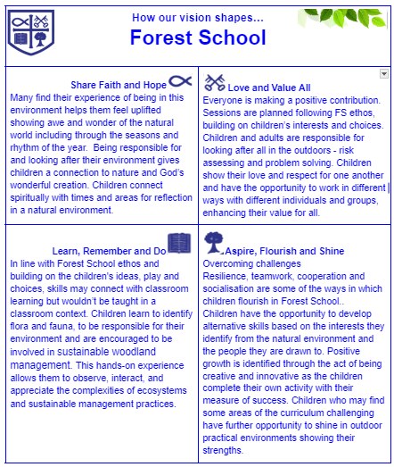

Children will have the opportunity to:

- Be reflective around campfires, reflection areas, in dens.
- Build shelters and hammocks.
- Climb and balance
- Use a range of tools from hand drills to bill hooks.
- Create a variety of knots and lashings for different purposes.
- Help to prepare wood, build, start a fire and understand the importance of fire safety.
- Prepare and cook food on an open fire.
- Track animals and bug hunt.
- Make a variety of items from jewellery to musical instruments.
- Collect, group and classify a range of flora and fauna.
- Study the seasons and the changing wildlife.
- Communicate in a range of games and work together to problem solve.
- Develop storytelling and character building in the outdoor environment.
- Develop gross and fine motor skills through play.

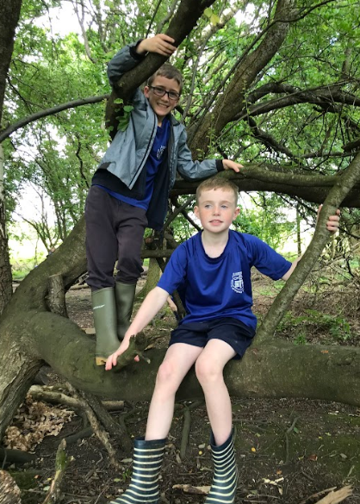
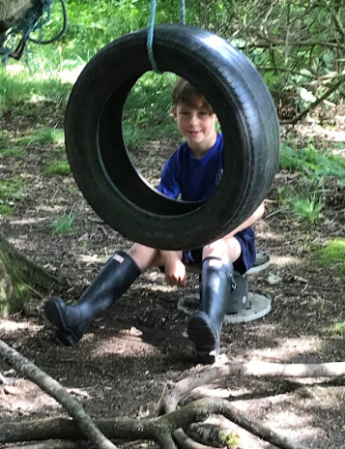
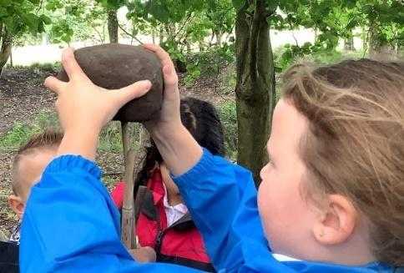
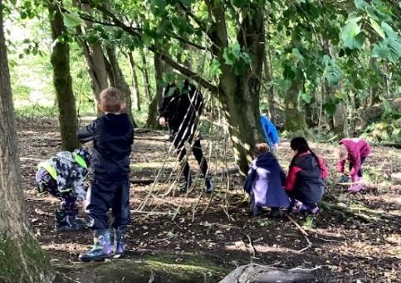

The structure of the Forest School Session

Before each session:
- A thorough sweep of the site will be carried out to check for any hazards, for example, litter, glass, animal faeces. Any such items will be removed using disposable gloves and will be put in plastic bags and disposed of accordingly. The school office will be informed.
- Pathways and trees will be checked for fallen or hanging dead branches that could cause injury and trip hazards such as bramble runners across paths will be moved.
- Weather conditions will be checked.

During each session:
- Participants will change into appropriate clothing and footwear.
- Alternative clothing will be offered where worn clothing is not appropriate and this will be judged by the Forest School Leader.
- Labelled sunscreen should be applied on sunny days which should be provided by parents. Children will apply their own suncream unless they are too young to do so.
- First sessions will incorporate a Health and Safety boundary walk and risk assessment of trees and plants, so they are aware of rules, dangers to avoid and safe play. This will be referred to every session.
- All sessions will use ‘Sticky Feet’ gathering chant so that children know how they will be gathered during sessions or in an emergency.
- At least one activity will be introduced during each session and will build on the children’s interests from the previous session.

To end each session:
- Reflection time: This could include meditation, mindfulness tasks and feedback of likes, dislikes, difficulties and challenges overcome.
- The site will be left tidied, and no trace left.

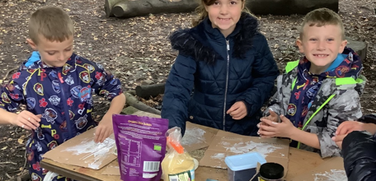

The Impact of St. Leonard’s Forest School

Many children will have new experiences during their forest school time and a broad range of activities will be available to act upon children’s interests and to learn new skills. The satisfaction that children feel when crafting something new and of use is a valuable learning experience for all children. Children will grow in confidence as a result of the freedom, time and space they are given in their learning. This allows them to demonstrate independence at each individual child’s rate.
The children will begin to understand, assess and manage their own risk and safety. This will allow the children to become more independent and show them that life comes with not only risk but also rewards. It also teaches them what their own limits are and that they can push through them. They will see that sometimes we don’t always get the desired result the first time but that doesn’t make us a failure, it helps us to grow, forcing us to try again in a different way. Forest school encourages and facilitates problem solving, logical thinking, self-reflection and evaluation.
Activities such as sharing tools and participating in play help teach the children to work together as a group, strengthening their bonds and social skills. The review time at the end of each session allows time for self-reflection and for all children to share and celebrate their successes.
The sensory experiences provided by Forest School helps prompt language development, a wider range of higher-level vocabulary that is learnt in situ, with hands-on experience. The adult can play a role of just observing, coming alongside, modelling, supporting, scaffolding or encouraging. Children develop an interest in the great outdoors and respect for the natural world around them. The changing seasons and weather offer a wealth of interest and opportunities.
We measure the impact of our curriculum through the images and videos of the children’s practical learning and talking to the children about their learning during reflection (pupil voice). These are included on the school website and on the school Facebook page so parents and other adults can see the images, where permission has been granted.
Our Forest School sessions will be delivered by qualified Level 3 Forest School leaders. They deliver this program following the guidance set out in this document. A copy of all policies and procedures will be shared with all participating adults and kept in the office. This contains vital information needed for each session which includes procedures in the event of an emergency etc.

Equality and Diversity:
All children will be included with all activities and no form of discrimination will take place; reasonable adjustments will be made to make it inclusive for all. Inclusion is a thread which runs through all the Forest School activities regardless of a child’s ability, disability, gender, race, culture, etc. St Leonard’s C of E Primary School has a Special Educational Needs Policy, an Inclusion Policy and an Equal Opportunities Policy which will be adhered to during Forest School sessions.

Roles and Responsibilities:
The Forest School Leader will have the overall responsibility for:
- Risk assessments for each session, pre-visit site checks and continuous safety monitoring.
- Planning for sessions, differentiation for individual children’s needs.
- Ensuring that once on-site rules are followed and continue to risk assess during the session.
- Ensuring necessary equipment is taken into woodland.
- Administration of first aid and checking first aid kit.
- Supervision of fire use, following procedures set out in this document
- Supervision of tools use, cleaning and storing.
- Organising emergency procedures.
- Ensure site is left as it was found after every session
Staff/ students / volunteers: will model good practice throughout the session, carry out delegated roles and responsibilities, extend children’s learning where appropriate by asking extending questions, support children to manage their own risk, remind children of rules and boundaries, be aware of dangers within Forest School, always monitor levels of safety and support the Forest School leader to run the sessions.
Evidence of sessions will be shown by photographs following each session to be uploaded onto the staff Google Drive and shared on the school website and school Facebook page.

