

Headteacher: Mrs Dawn Lindley B.Sc (Hons) QTS CofEPQH
Weekly Newsletter Friday 17th January 2025

You can also see more information about us on our school website: www.langho-st-leonards.lancs.sch.uk
Follow us on facebook: Langho and Billington St Leonards Facebook page

Worship
This week’s worship was about Jesus’s parables. We began with The Good Samaritan on Monday and thought about how this links to our school badge values ‘Love and Value all’. This parable teaches us to do exactly that!
We were treated to lovely worship in Church led by Falcons this morning about the Parable of the three servants. This helped us to think about our talents and how God wants us to use them so we can ‘Aspire, Flourish and Shine. Especially when this helps others! Thank you to our parents and supporters who joined us.
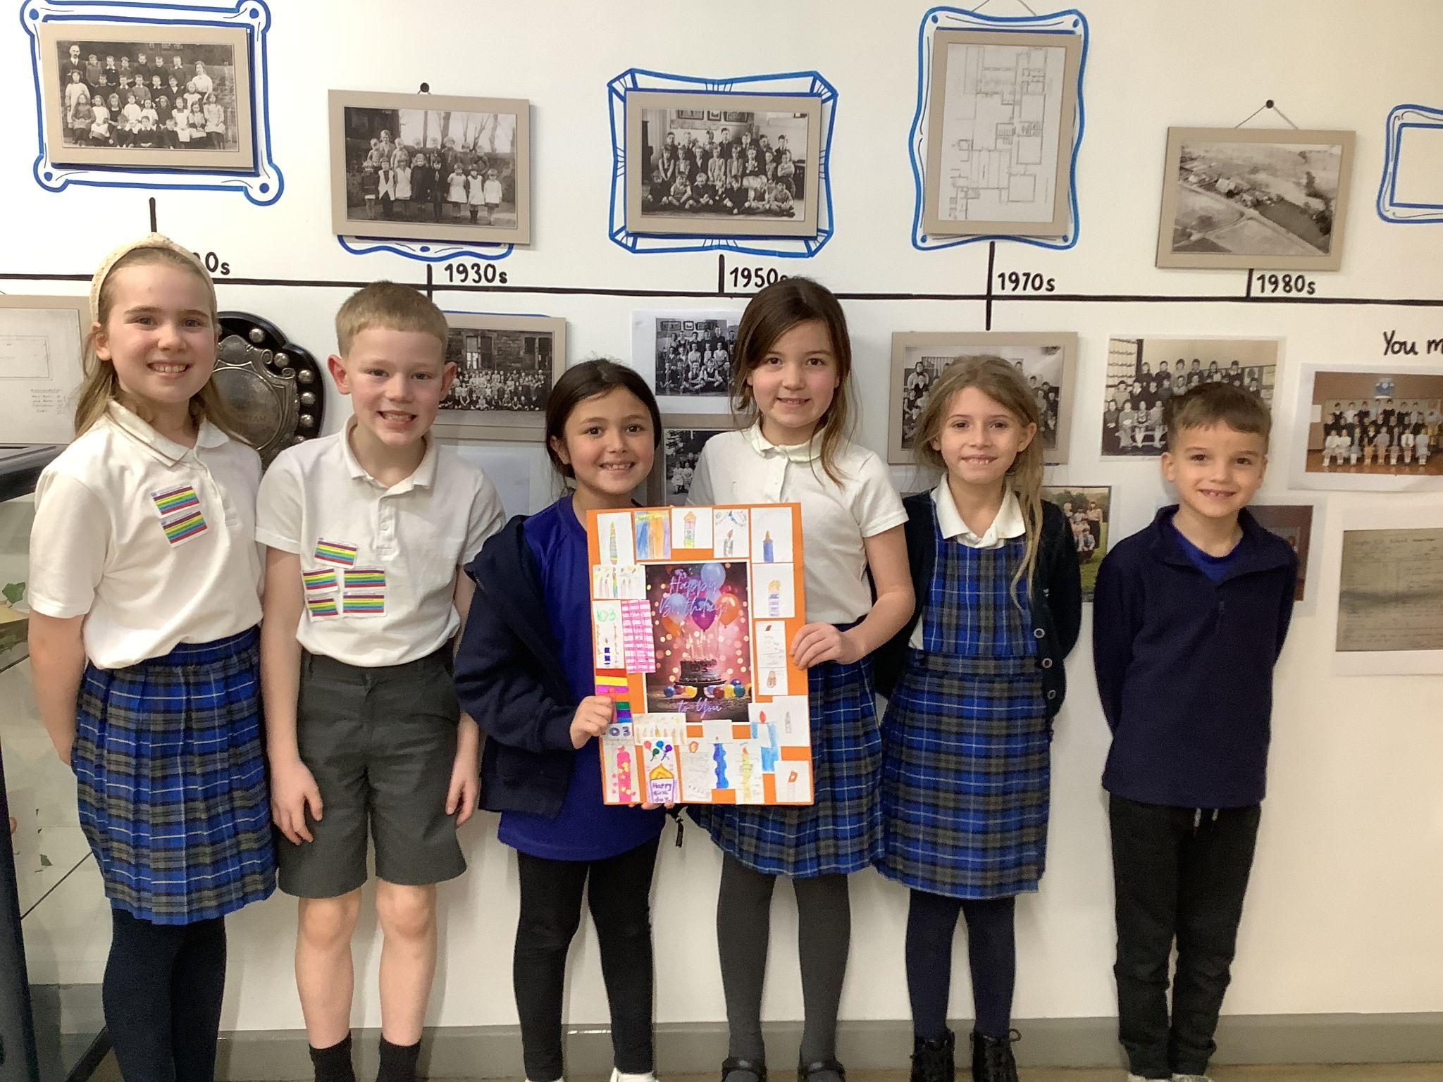
Happy 103rd Birthday Mabel!
Our Year 3 and Year 4 children made a very special birthday card decorated with 103 candles for a lady who reaches this age on 20th January. Unfortunately, Mabel has no children nor any other family of her own and so the staff in her care home have reached out to schools who could help to make Mabel’s day.
What a lovely card - I am sure she will be thrilled!

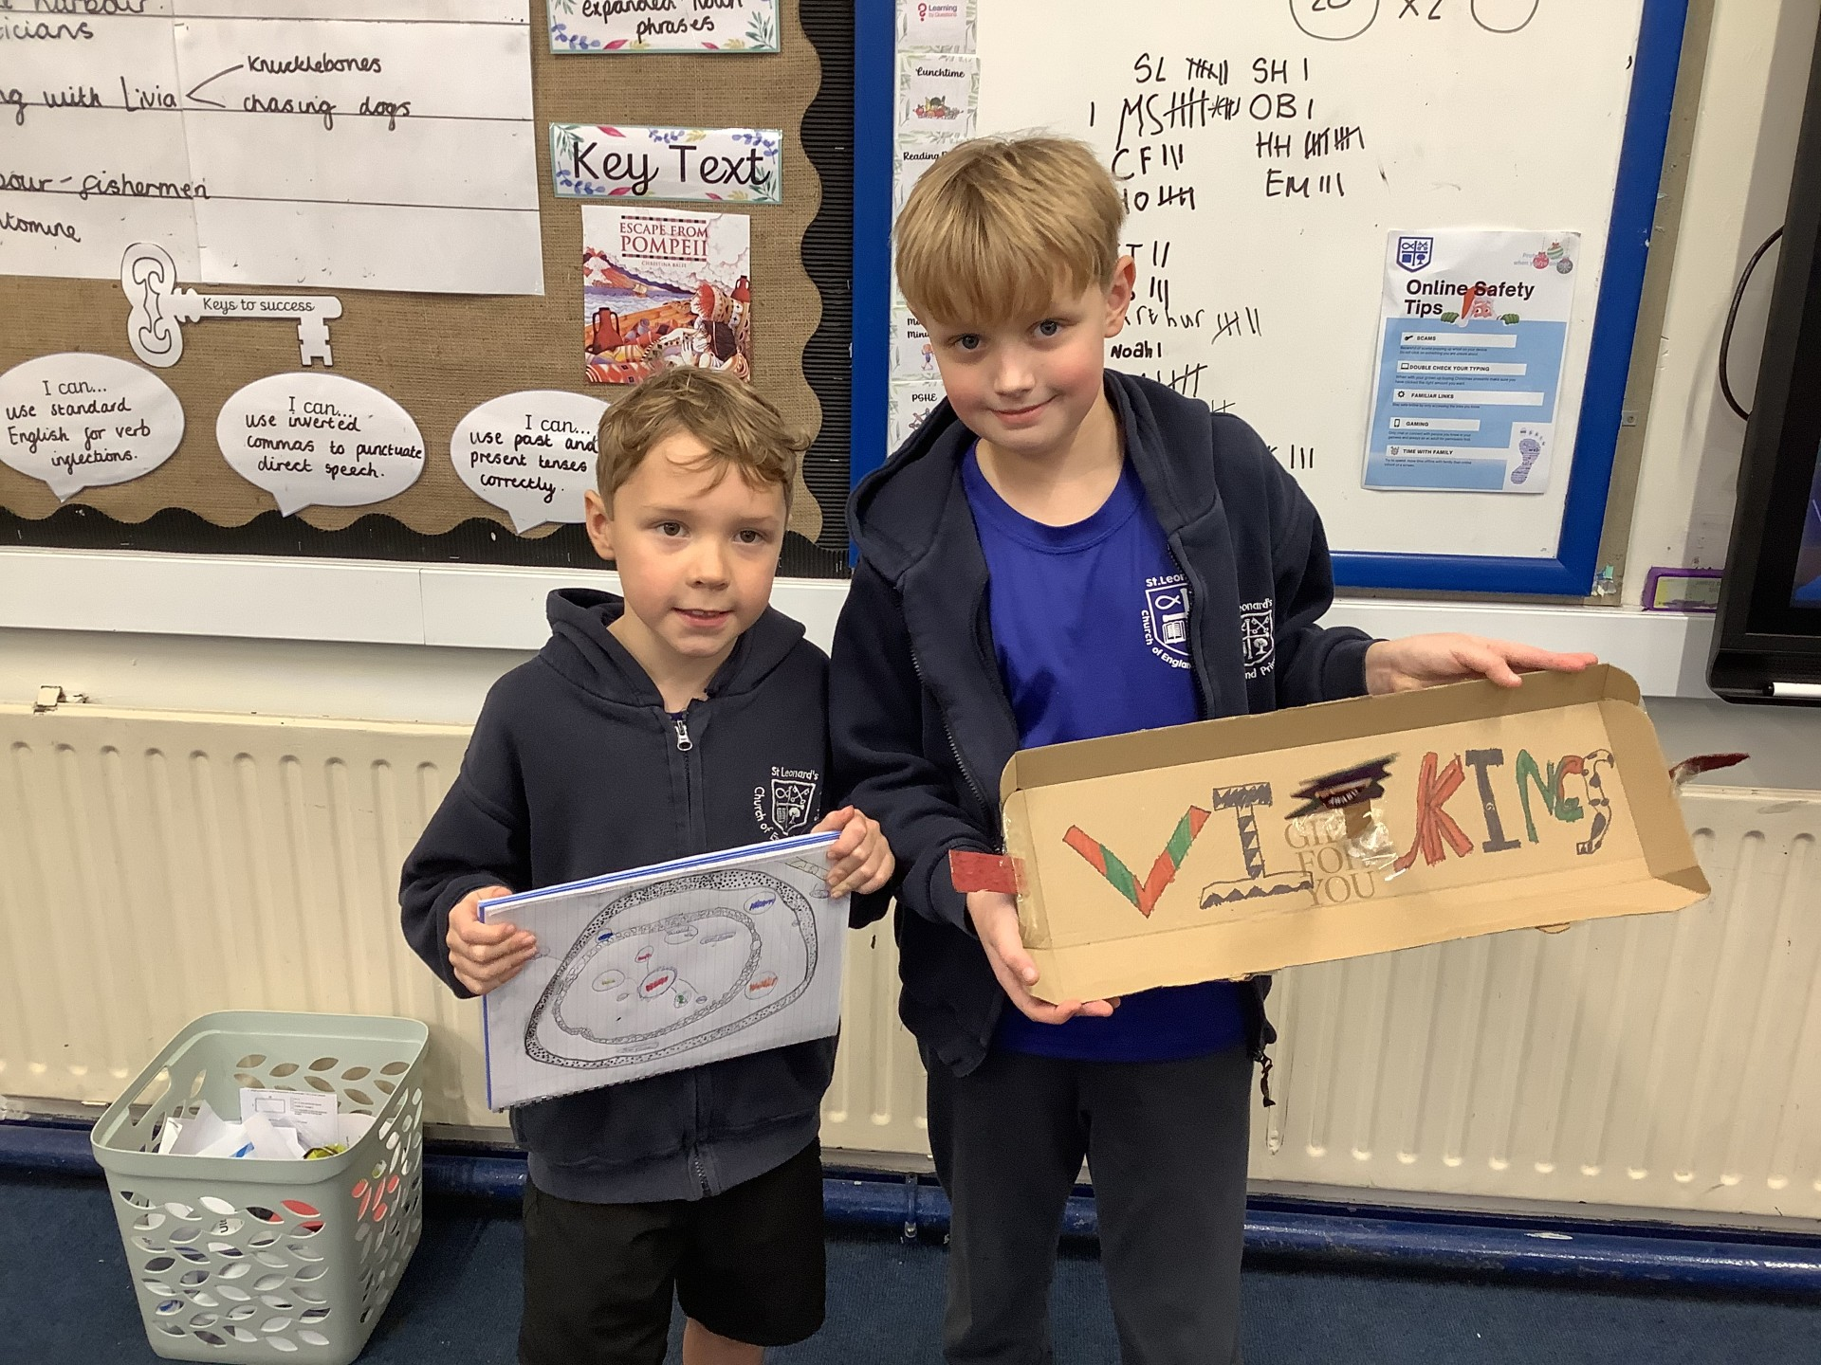
Home Learning
Some fabulous home learning from these two super Kingfishers!
Well done boys!

Spring Parent/Carer evening 11th February 2025
Bookings are now open for Parent/Carer evening via the school website.
Lancashire Schools Football Cup Tournament
We are very proud of both the Girls football team and the boys Football A team who competed at the Lancashire Schools Football Cup Tournament today. Both teams played extremely well and were brilliant ambassadors for our school. Special thanks go to Mr Steele for being the girls football coach - a wonderful help.
Well done everyone!
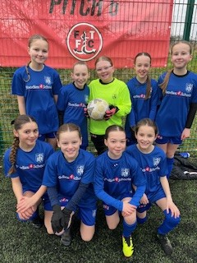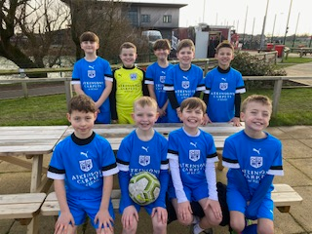
RSPB Big Schools Bird Watch 2025!

We have registered to take part in the Big Schools Bird watch ran by the RSPB and would like to ask for your help to attract as many birds to our school grounds as possible. Please help us by sending in any bird feeders or even a bird table you may have and are not using. Or make your own at home with your children and send them in. Please may we request that any bird cakes are made of seeds and not peanuts as we are a ‘nut free’ school!
Follow the link below if you are interested in taking part in this year’s Big Garden Bird watch at home.
https://www.rspb.org.uk/whats-happening/big-garden-birdwatch

Considerate and careful parking and driving
It has been witnessed by staff and reported to us by other parents that cars are stopping in the middle of the road outside of school to allow parents / carers / children to get out of cars resulting in cars being held up.
We realise that at times the school run and finding a parking space can be stressful - however please can we ask that when parking, dropping off, collecting and driving around school that all drivers are considerate and kind and respectful to each other as role models to our children.
We are very lucky to be able to use the top car park at Mytton Fold - please use this space as we have been asked not to use the community centre car park unless you are accessing Coolkidz.
BELOW IS A MESSAGE FROM LANCASHIRE CONSTABULARY REGARDING INCONSIDERATE PARKING. PLEASE DISTRIBUTE THIS MESSAGE TO ANYONE THAT MAY BE COLLECTING YOUR CHILD/CHILDREN FROM SCHOOL.

Dear Parent / Guardian
It has been brought to our attention that a few vehicles are parking adjacent to the solid while lines in the middle of the road near to the Petre Arms pub at both drop off and pick up times.
Parking adjacent to solid white lines in the middle of the road is an offence and carries a penalty of £100 fine and 3 points on your licence.
This is already a busy road and with the school traffic and children being escorted in and around the area it heightens the need for motorists to park legally and sensibly.
I will be monitoring the area at busy times and if your vehicle is seen you may receive a fixed penalty notice
PLEASE REFRAIN FROM PARKING ILLEGALLY
Regards
Ribble Valley Neighbourhood Team
This Week’s Attendance

 | Class | % Attendance this week
 | Falcons | 100
 | Robins | 98.6
 | Herons | 98.1

Diary Dates
Spring 1
Thursday 23rd January | 4-6pm Ribble Valley Sportshall athletics - Y5&6. (further details to follow)
Thursday 30th January | KS1 trip to Imagine That
Thursday 30th January | Year 5 Mayan Archeology day (further details to follow)
3rd- 9th February | Children’s mental Health week - activities in school
Friday 7th February | Y6 Young Voices Concert at Coop Live.
Friday 7th February | 12.30-2.30pm Ribble Valley Sportshall athletics - Y5&6. (further details to follow)
Tuesday 11th February | Parents’ Evening - booking now open on the website
Friday 14th February | 3.30pm School closes for half term
Monday 24th February | 8.40am School opens after half term


Absence and Lateness
This is a further reminder that the School day begins at 8:55am. The gates are now open from 8:40am and shut at 8:55am. Please do your best to get children to school for 8.40am, when the gates open. Once the gate is shut, please take your children to the office through the main school entrance.
To safeguard all of our children effectively, ALL CHILDREN arriving after the gates are shut MUST BE SIGNED IN BY THEIR ADULT at the front office.
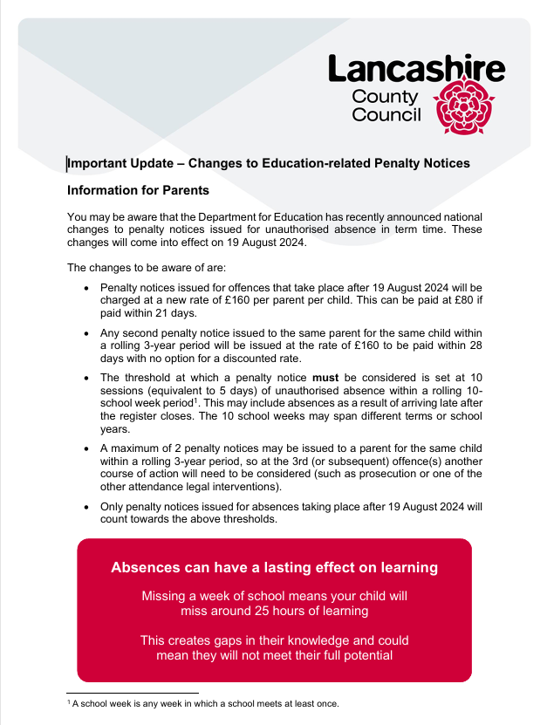

Reading and Reading Record Books
From babies to children in their early years and all the way through to early teens, reading brings profound and wide-ranging benefits that can have a lifelong positive impact on children’s lives. Children who read: are more likely to overcome disadvantages caused by inequalities; are more likely to be happier, healthier and experience better mental wellbeing and self-esteem; are more likely to do better at school and make more progress across the curriculum and are more likely to develop empathy and creativity.
Shared reading creates opportunities for joint attention and emotional closeness between a child and their parent or carer. It is also a wonderful way to be involved in your child’s education and development.
Reading is important to us at St Leonard’s and is really important that children read, not only at school but at home as well. With this in mind, please could all parents and carers ensure that children read at home daily. When your child has read at home, please initial their reading record book so that we can see how regularly they are reading at home.
Please ensure that your child’s reading book and reading record book are in school with them every day as teachers will be using and checking them regularly.

Parents with Prams
If you are bringing or collecting a child in Reception, Year 1 or Year 2, and you have a pram with you, please wait at the double white doors near the ramp that goes into the hall. In the morning, there will be a member of staff to ensure that your child reaches their classroom and at the end of the school day, staff will bring your child to you as soon as they are able.
Crossing Patrol
Unfortunately there will be no crossing patrol attendant for the foreseeable future. Please take extra care when using pavements and crossing over the road outside school and drive with extra consideration. If your child uses the crossing after school, please make sure they know that they are able to ask a member of staff in school or the office to assist them crossing the road.
If anyone is interested in taking over this position, please contact Mr Simmons on 07831 309599.
Appointments during school hours
Can we please request that routine appointments, i.e. dentist, doctors, opticians etc, be made for outside of school hours where at all possible. Evidence of the appointment, e.g. a letter, appointment card or email, should be provided if this is unavoidable during school hours. Thank you for your support with this.
Holidays in term time
We have had a very large number of holiday requests for holidays to be taken in term time. We would like to stress the importance of not taking children out of school for holidays.
Please note that without at least 2 weeks prior notice and for all absence requests of more than 5 days (10 sessions) in a term or 7 days (14 sessions) over 2 consecutive terms, results in fines being issued from the Local Authority. This fine is currently £120 per child per parent (Including step parents) but is increasing in August 2024 to £160 per child per parent (Including step parents).
Little Lennie’s Nursery

If you have a child born in April 2024 onwards and you would like a place in Little Lennie’s Pre-school from September 2027 onwards, could you please contact Mrs Bolton in the school office.

Little Lennie’s is proving to be extremely popular and we are full with waiting lists for both 2024/25 and 2025/26 intakes. We are already taking bookings for 2026/27 and even 2027/28!


Facebook
Our facebook page includes regular updates - please follow and like!
Langho and Billington St Leonards Facebook page

Help, Advice and Support
Please see the new page on our school website for links and phone numbers for a variety of sources of help and support such as community groups, housing, domestic abuse, mental health and food banks. https://www.langho-st-leonards.lancs.sch.uk/parent-info/help-and-support
We have also updated our Health and Wellbeing page with links to help your child regarding mental health and wellbeing.
https://www.langho-st-leonards.lancs.sch.uk/parent-info/health-and-wellbeing
New links will continue to be added. If you know of any other support sources that we could add, please contact the office staff.
Nut Free School
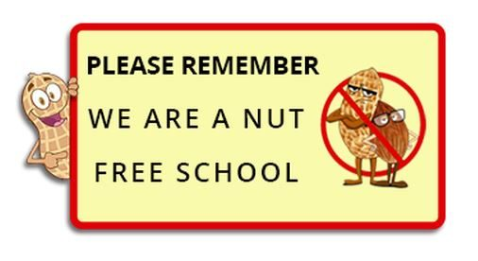
Please remember to be careful when packing children’s lunches and snacks sent into school. Products containing any type of nuts are not allowed due to children with nut allergies in school. Kinder Bueno and Nutella snacks contain hazelnuts - please leave these at home.

Many thanks for your cooperation
Named Items PLEASE HELP!
Children take off cardigans and jumpers and leave them around school or the playground, if they are not named then it is almost impossible to reunite them with the correct owner. Please ensure that ALL items belonging to your child are clearly named using a ball point pen in the label (including coats, and lunch bags/boxes) to ensure that any mislaid items can be promptly returned. Thank you.
There is an awful lot of lost property accumulation again - please check under the canopy (KS2) or outside of Eagles classroom (KS1) at the end of each school day if you have lost something.

Jules School Special
Join us this January, here at Jules restaurant where we’ve got an exciting deal for the whole family to enjoy!
Enjoy any hand-stretched pizza from our main menu for just £9.95 each, on Wednesdays & Fridays from 3:00pm – 5:30pm.
Check out our pizzas here: https://www.myttonfold.co.uk/jules-restaurant/
Book your table with us today on: 01254 240 662




