
Langho and Billington St. Leonard’s Church of England Primary School

www.langho-st-leonards.lancs.sch.uk Langho and Billington St Leonards Facebook page

Week beginning 12th October 2026
NEWS
Worship

Bishop Philip joined us on Wednesday for a beautiful service about Saint Martin showing a deep compassion towards the poor. His service included children having the opportunity to act out the scene, bringing the story from the bible to life.

Robins class worship

St. Leonard’s Day
Please pop these dates in your diary as we celebrate our school and parish patron saint!
Friday 16th October - Non-uniform day in exchange for chocolate (no nuts please) / £2 which will go towards the church family fun day.
Saturday 17th October - Family Fun Day - At St. Leonard’s Church - all welcome. Further information to follow soon!

Cross Country
We are bursting with pride to share that our school came first overall at the cross country event.
Our boys’ A team took 1st place and our girls’ A team came 2nd; an outstanding result with around 350 children competing in total! Also a special shout out to Harper, who placed 1st overall! Every single one of our runners demonstrated determination, resilience and perseverance all the way through a tricky running course.
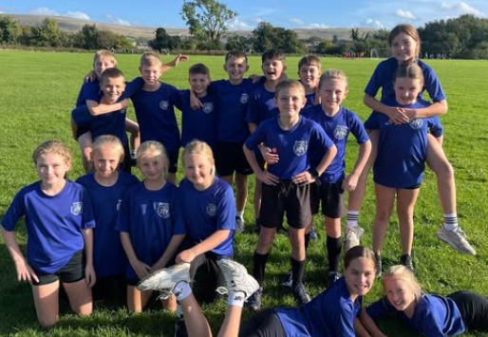

Traditional Sports Day

Amazing effort from our Year 3 and 4 children at the Traditional Sports Day event! From sack races to ‘fill the bucket’, and finishing by working together in a tug of war — an amazing time was had by all. Well done, team! We are so proud of you all!
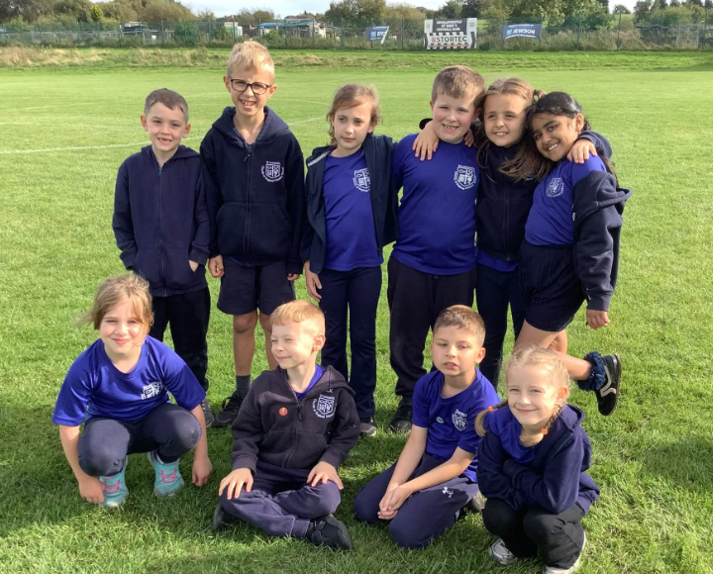

Kids Cup

Our A team enjoyed an excellent run in the Kids Cup, reaching the quarter-finals unbeaten and without conceding a single goal.
Unfortunately, despite a determined performance, the team were narrowly eliminated following a penalty shootout. Our boys should be extremely proud of their achievement and the commitment they demonstrated, despite playing with each other for the first time. Well done, boys!

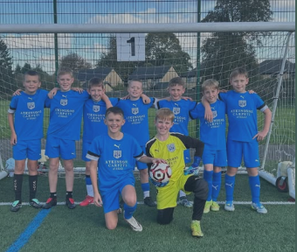

Girls football

A massive well done to our amazing girls’ football team who gave it absolutely everything last week! We are so incredibly proud of your hard work, effort and determination on the pitch.
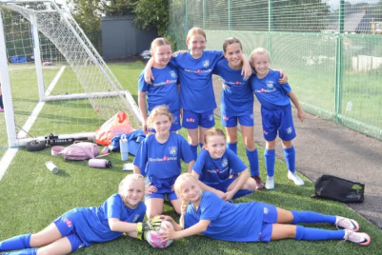

More running news….

Mike is very proud to have run alongside Rugby Legend Sir Kevin Sinfield during the "Extra Mile" on Saturday the 3rd October, as part of his "7 in 7: The Grand Finale" challenge, which has raised over 1.3 million £ so far in aid of the MND Association, supporting those living with or affected by MND.

Mike has been raising money for the MNDA since his Opa (grandad) Kees passed away from MND on the 9th October 2023 at the age of only 66.

Opa Kees suffered with Bulbar-onset ALS which is a form of MND. ALS is a rare neurological disease that affects motor neurons, those nerve cells in the brain and spinal cord that control voluntary muscle movement. Voluntary muscles are those we choose to move to produce movements like chewing, walking, and talking. The disease is progressive, meaning the symptoms get worse over time. Like any form of MND, ALS has no cure and there is no effective treatment to reverse its progression. Kees’ biggest and final wish is for a cure to be found against MND, so in the future, nobody would have to suffer like he did.

Last year his dad ran the London, Chicago and the Amsterdam Marathon as part of #TeamMND. This year he has already taken on London, Leeds and Berlin, and later on this year he will be running the New York City Marathon!

Mike would like to follow his footsteps and do many running races, as well as other fundraising events and activities. Last Saturday was a very special day, and it was great to see so many people of the MND community come together and fight for such an important cause!



School lunches

Please Note: As of the 2nd November, children’s school lunches will be increasing to £3.10 per day.

As always, children can order daily if they wish to have a school lunch. Please contact the office if you would like an up to date menu.
New tool for school holiday and events tracking
We are pleased to be able to provide you with a brand new tool which has been designed by one of our parents, James MacMahon.
Please go to https://schoolhols.online/lbsl to view our terms dates, holidays and upcoming events. It works on any phone or computer, with no app or account needed. You can also tailor the app to just show the events relative to your child / children.
If you would like the dates in your own calendar (i.e. outlook, google etc), the page shows you how to do this, including an option to subscribe (no charges are involved) so changes made by school staff are added automatically. However, calendar apps pick up changes on their own schedule, so it is advised to go to https://schoolhols.online/lbsl for the most up to date information.
You can also scan the following QR code which will take you directly to https://schoolhols.online/lbsl



We think this is an absolutely wonderful tool and would appreciate any feedback you may have!

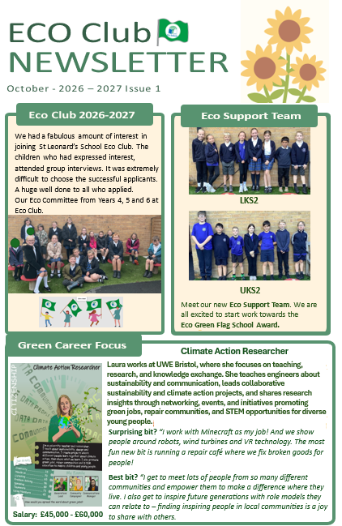
Autumn Sports Events and Intents:

- League A Football – Monday 9th November: To develop valuable physical, social and communication skills through working as a team to achieve a common goal.
- KS2 Panathlon – Friday 13th November: To work as a team to develop social and physical skills whilst taking part in engaging and inclusive activity stations.
- League B Football – Monday 16th November: To develop valuable physical, social and communication skills through working as a team to achieve a common goal.
- Sportshall Athletics – Tuesday 24th November: To participate in a range of activities focusing on agility, balance and coordination whilst working as part of a team.
- Football Competition – Friday 27th November: To work successfully as a team to achieve a common goal in a competitive environment.
- League B Football – Tuesday 8th December: To develop valuable physical, social and communication skills through working as a team to achieve a common goal.
- Year 1/2 Kurling – Thursday 10th December: To develop kurling skills and work as a team to compete successfully against other schools.

Attendance
Learning days lost to term-time holidays so far this year: 42
Holidays during school time can only be authorised in exceptional circumstances and time off school is lost learning time. Please do not book holidays during school term time. For our term dates, please see the school website or the calendar below. https://www.langho-st-leonards.lancs.sch.uk/page/?title=Term+Dates&pid=132

Medical Appointments
Please ensure that medical appointments (including dental appointments) during school hours are kept to a minimum and we ask that these are scheduled outside of school hours wherever possible. Every lesson missed is a missed learning opportunity.
Please also note that our office staff are extremely busy. If there is an unavoidable medical appointment for which your child(ren) will need to be collected early, please let the office staff know in the morning. If you turn up unexpectedly to collect your child(ren) there will be a wait.

 | Class Attendance Year to Date
1st | Reception | 100%
2nd | Year 3 | 97.7%
3rd | Year 5 | 96.8%


Primary School Admissions
Primary school admissions for 2027 Reception starters are open.
(Closing date: 15th January 2027)
If you, or someone you know are looking for a reception place for September 2027, we would be delighted to show you our wonderful school.

St. Leonard’s Open Evening
Thursday 22nd October 2026
5:30-7:00pm

Daytime ‘School in Action’ Tours
(Please contact the school office to book
01254 247156 info@langho-st-leonards.lancs.sch.uk)
Wednesday 4th November
Tuesday 10th November
Thursday 19th November
Monday 23rd November
Wednesday 2nd December

Please see our school website for more admissions details: https://www.langho-st-leonards.lancs.sch.uk/page/?title=Admissions&pid=38

Lancashire County Council admissions website: https://www.lancashire.gov.uk/schools-and-education/school-admissions/starting-primary-school/
Secondary School Admissions

Secondary school admissions are open. The closing date is 31st October 2026.

https://www.lancashire.gov.uk/schools-and-education/school-admissions/starting-secondary-school/


Below please find the link to Ribble Valley Foodbank.
https://ribblevalley.foodbank.org.uk/get-help/
Ribble Valley Foodbank is open on Fridays between 09:30 and 12:30 at Trinity Methodist Church and Community Hub, Parson Lane, Clitheroe, BB7 2JY.
The Olive Branch Advice Hub is also open at the same time, providing free, confidential advice and support.
Please note that you will need a voucher code to collect a food parcel - use the ‘Get help’ tab to find out more about getting both food parcels and free advice.


Church Facebook
Please see the link below for the church parish facebook page.

https://www.facebook.com/share/1A9VDHpwfJ/
REMINDERS
Labelled Items
We have already found a huge number of unnamed / unlabelled items of clothing. Please ensure that ALL of your child’s items (coats, jumpers, lunchboxes, water bottles, bookbags) are clearly labelled with your child’s name. (A mark or item that only your child can identify is not sufficient.)
Labelled items are returned to children. Unlabelled items are left in lost property, available to check in the friendship area after-school. However, if these are not claimed in a timely manner, they will be made available on the rail in the office entrance area.
For further details, please see our uniform policy available on our website:
https://www.langho-st-leonards.lancs.sch.uk/page/?title=School+Uniform&pid=136

ACHIEVEMENTS OUTSIDE OF SCHOOL
DIARY DATES
Autumn 1 - 2026
Thu 15th Oct | Reception -Y6 Parents’ Evening - booking will open on Monday 28th September 6:00pm
Fri 16th Oct | St. Leonard’s Day - Non-uniform day in exchange for chocolate / £2 donation (Going towards church family fun day 17th October)  ‘Bangers & Bangers’ after school at St. Leonard’s Church - please see poster below for more details. Please contact the school office if you would like to attend.
Sat 17th Oct | Family Fun Day at St. Leonard’s Church - Please see poster below
Wed 21st Oct | Flu Vaccines - Details will be sent directly from Intrahealth - please look out for the email.
Thu 22nd Oct | 9:00am - Wrens class-led worship in St. Leonard’s church
Thu 22nd Oct | 5:30pm-7:00pm Reception 2027 Starters’ Open Evening
Fri 23rd Oct | 2:45pm - Reception Class Concert - School Hall
Fri 23rd Oct | 3:30pm - School closes for half-term
Autumn 2 - 2026
Mon 2nd Nov | 8:40am - School re-opens for children after half-term
Wed 4th Nov | Reception 2027 Starters ‘School In Action’ Tour - please contact the school office to book (01254 247156)
Tue 10th Nov | Reception 2027 Starters ‘School In Action’ Tour - please contact the school office to book (01254 247156)
Thu 19th Nov | Reception 2027 Starters ‘School In Action’ Tour - please contact the school office to book (01254 247156)
Mon 23 Nov | Reception 2027 Starters ‘School In Action’ Tour - please contact the school office to book (01254 247156)
Wed 2nd Dec | Reception 2027 Starters ‘School In Action’ Tour - please contact the school office to book (01254 247156)
Thu 3rd Dec | Pantomime - in school
Wed 9th Dec | EYFS Nativity (10.30am and 2.30pm - in school hall)
Thu 10th Dec | KS1 - Carols in Church - 5pm  KS2 - Nine Lessons and Carols at Old Langho Church - 7pm
Fri 18th Dec | 1:30pm - School closes for all children for Christmas holidays

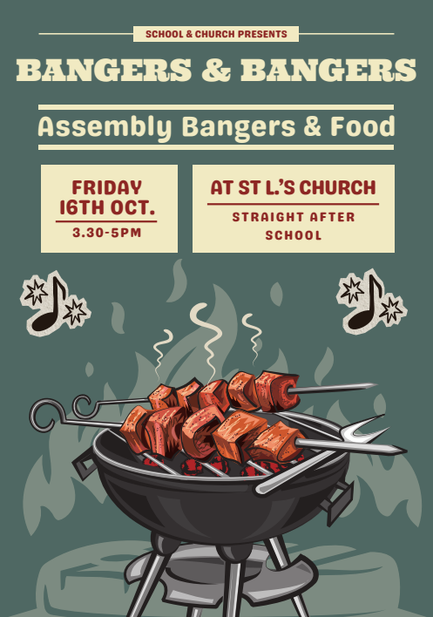
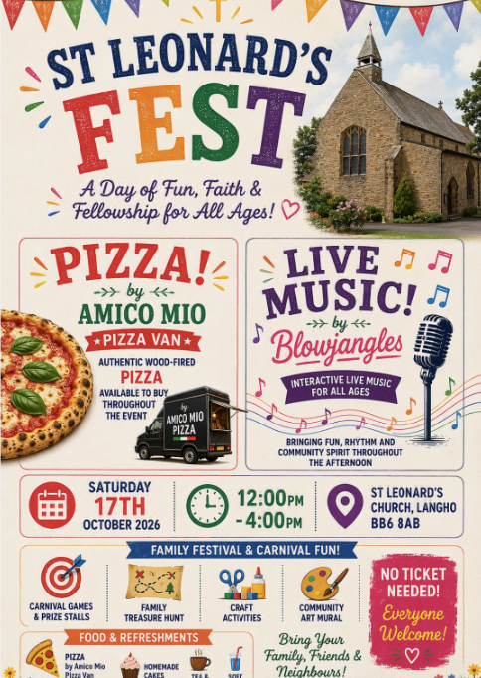

Join us this Halloween at Mytton Fold, for some family-friendly fun, featuring the team from @happilyeverafterprincesses with some added Hocus Pocus magic

Choose from a morning or afternoon session for just £20 per child and enjoy:

 Kids Breakfast or Lunch Buffet, plus jugs of cordial
 90 minutes of magical entertainment with live Hocus Pocus characters
 Spooky singalongs
 Wicked Halloween games

Costumes are highly encouraged, so dress to impress and get ready for a frightfully fun Halloween! 

*Adults tickets are £5.00 and include tea and coffee on arrival.
Pre-book your tickets for both sittings now: https://bit.ly/4w63F1m

They can be booked directly on ticketsource here: https://www.ticketsource.com/mytton-fold-hotel



