
Langho and Billington St. Leonard’s Church of England Primary School

www.langho-st-leonards.lancs.sch.uk Langho and Billington St Leonards Facebook page

Week beginning: 28th September 2026
NEWS
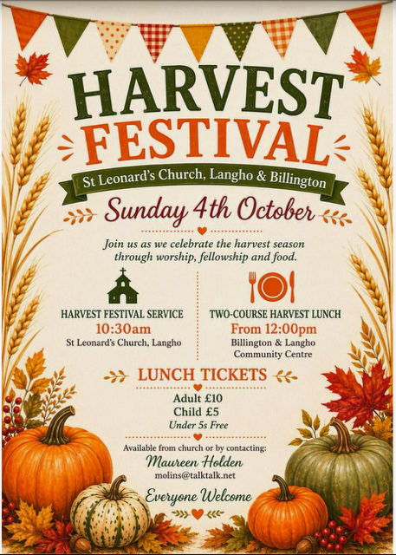
Worship

Bishop Philip joined us on Wednesday for a beautiful service about Saint Martin showing a deep compassion towards the poor. His service included children having the opportunity to act out the scene, bringing the story from the bible to life.

Harvest Festival
On Friday 2nd October, please bring donations of ‘storecupboard food’ e.g tins, dried pasta, jars or money in an envelope.
On Sunday morning, please join us for the Harvest Festival service, which the school choir will be singing at. All welcome!

St. Leonard’s Day
Please pop these dates in your diary as we celebrate our school and parish patron saint!
Friday 16th October - Non-uniform day in exchange for chocolate (no nuts please) / £2 which will go towards the church family fun day.
Saturday 17th October - Family Fun Day - At St. Leonard’s Church - all welcome. Further information to follow soon!

Sports News
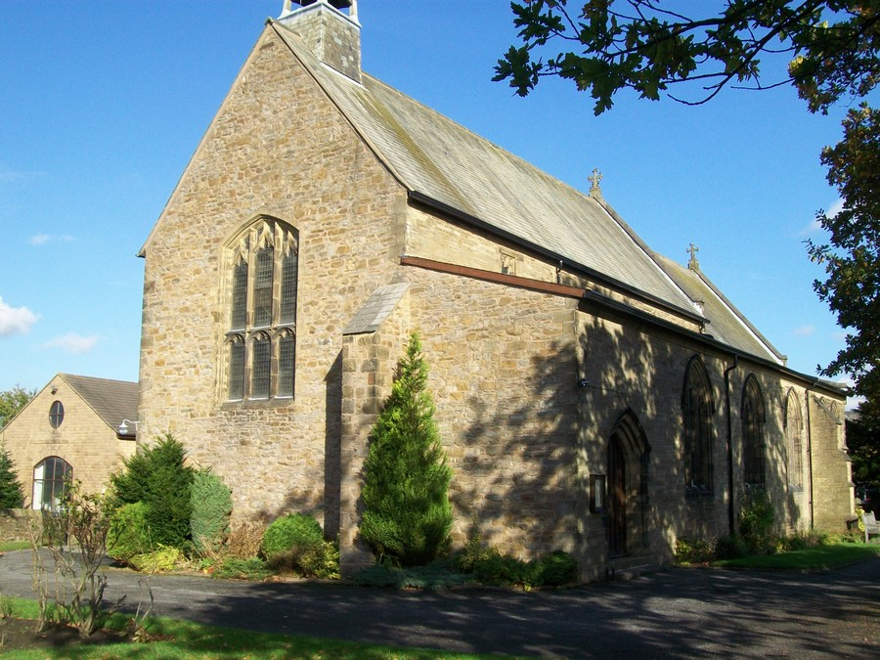
Church Facebook
Please see the link below for the church parish facebook page.

https://www.facebook.com/share/1A9VDHpwfJ/
Attendance
Learning days lost to term-time holidays so far this year: 33
Holidays during school time can only be authorised in exceptional circumstances and time off school is lost learning time. Please do not book holidays during school term time. For our term dates, please see the school website or the calendar below. https://www.langho-st-leonards.lancs.sch.uk/page/?title=Term+Dates&pid=132

Medical Appointments
Please ensure that medical appointments (including dental appointments) during school hours are kept to a minimum and we ask that these are scheduled outside of school hours wherever possible. Every lesson missed is a missed learning opportunity.
Please also note that our office staff are extremely busy. If there is an unavoidable medical appointment for which your child(ren) will need to be collected early, please let the office staff know in the morning. If you turn up unexpectedly to collect your child(ren) there will be a wait.

 | Class Attendance 21st-25th September
1st | Falcons | 99.31%
2nd | Swifts | 99.17%
3rd | Herons | 98.97%

Autumn 1 Sports Events and Intents:

28/09 Kids Cup Football Year 5 and 6: To work successfully as a team to achieve a common goal within a competitive environment, developing teamwork, resilience and communication.

1/10 Cross-Country Year 5 and 6: To develop stamina, determination and resilience whilst challenging themselves to perform to the best of their ability.

9/11 League A Football Year 5 and 6: To develop teamwork, communication and tactical skills whilst competing together to achieve a common goal.

16/11 League A Football Year 5 and 6: To develop valuable physical, social and communication skills through working as a team to achieve a common goal.
New tool for school holiday and events tracking
We are pleased to be able to provide you with a brand new tool which has been designed by one of our parents, James MacMahon.
Please go to https://schoolhols.online/lbsl to view our terms dates, holidays and upcoming events. It works on any phone or computer, with no app or account needed. You can also tailor the app to just show the events relative to your child / children.
If you would like the dates in your own calendar (i.e. outlook, google etc), the page shows you how to do this, including an option to subscribe (no charges are involved) so changes made by school staff are added automatically. However, calendar apps pick up changes on their own schedule, so it is advised to go to https://schoolhols.online/lbsl for the most up to date information.
You can also scan the following QR code which will take you directly to https://schoolhols.online/lbsl

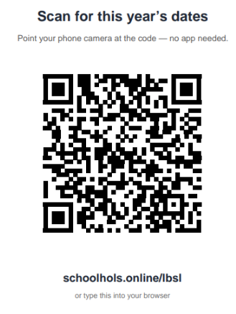

We think this is an absolutely wonderful tool and would appreciate any feedback you may have!


Primary School Admissions
Primary school admissions for 2027 Reception starters are open.
(Closing date: 15th January 2027)
If you, or someone you know are looking for a reception place for September 2027, we would be delighted to show you our wonderful school.

St. Leonard’s Open Evening
Thursday 22nd October 2026
5:30-7:00pm

Daytime ‘School in Action’ Tours
(Please contact the school office to book
01254 247156 info@langho-st-leonards.lancs.sch.uk)
Wednesday 4th November
Tuesday 10th November
Thursday 19th November
Monday 23rd November
Wednesday 2nd December

Please see our school website for more admissions details: https://www.langho-st-leonards.lancs.sch.uk/page/?title=Admissions&pid=38

Lancashire County Council admissions website: https://www.lancashire.gov.uk/schools-and-education/school-admissions/starting-primary-school/
DIARY DATES
Autumn 1 - 2026
Tue 6th Oct | 2:00-3:00pm Preschool Stay and Play - please contact the school office to book
Tue 6th Oct | 3:30pm-4:15pm Y1-Y6 ‘Show and Share’ Parents/Carers are invited into class after school to look at your child’s books with them. No booking necessary.
Wed 7th Oct | 9:00am - Robins class-led worship in St. Leonard’s church
Thu 8th Oct | 2:00-3:00pm Preschool Stay and Play - please contact the school office to book
Mon 12th Oct | Individual and Siblings Photos (non- St. Leonard’s siblings from 8:30)
Thu 15th Oct | Reception -Y6 Parents’ Evening - booking will open on Monday 28th September 6:00pm
Fri 16th Oct | St. Leonard’s Day - Non-uniform day in exchange for chocolate / £2 donation (Going towards church family fun day 17th October)
Sat 17th Oct | Family Fun Day at St. Leonard’s Church - Please see poster below
Wed 21st Oct | Flu Vaccines - More details to follow
Thu 22nd Oct | 9:00am - Wrens class-led worship in St. Leonard’s church
Thu 22nd Oct | 5:30pm-7:00pm Reception 2027 Starters’ Open Evening
Fri 23rd Oct | 2:45pm - Reception Class Concert - School Hall
Fri 23rd Oct | 3:30pm - School closes for half-term
Autumn 2 - 2026
Mon 2nd Nov | 8:40am - School re-opens for children after half-term
Wed 4th Nov | Reception 2027 Starters ‘School In Action’ Tour - please contact the school office to book (01254 247156)
Tue 10th Nov | Reception 2027 Starters ‘School In Action’ Tour - please contact the school office to book (01254 247156)
Thu 19th Nov | Reception 2027 Starters ‘School In Action’ Tour - please contact the school office to book (01254 247156)
Mon 23 Nov | Reception 2027 Starters ‘School In Action’ Tour - please contact the school office to book (01254 247156)
Wed 2nd Dec | Reception 2027 Starters ‘School In Action’ Tour - please contact the school office to book (01254 247156)
Fri 18th Dec | 1:30pm - School closes for all children for Christmas holidays



