
Langho and Billington St. Leonard’s Church of England Primary School

www.langho-st-leonards.lancs.sch.uk Langho and Billington St Leonards Facebook page

Week beginning: 21st September 2026
NEWS
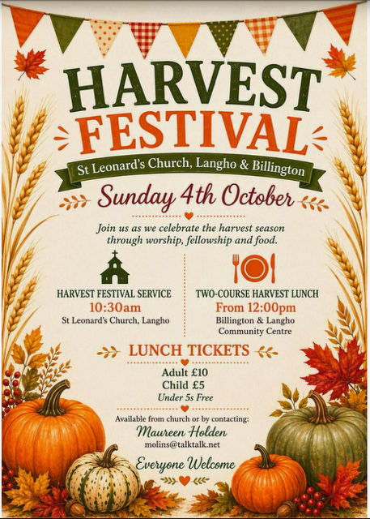
Worship

Well done to Swifts class who led us in worship on Wednesday. You all spoke so clearly and did a great job of telling us all about Miriam, Moses’ older sister from the Old Testament. Thank you for giving us really helpful ways that we can be like Miriam in our lives today by listening, speaking out when we need to and having courage.

Our next class-led worship will be by Robins class on Wednesday 6th October.

Harvest Festival
On Friday 2nd October, please bring donations of ‘storecupboard food’ e.g tins, dried pasta, jars or money in an envelope.
On Sunday morning, please join us for the Harvest Festival service, which the school choir will be singing at. All welcome!

St. Leonard’s Day
Please pop these dates in your diary as we celebrate our school and parish patron saint!
Friday 16th October - Non-uniform day in exchange for chocolate (no nuts please) / £2 which will go towards the church family fun day.
Saturday 17th October - Family Fun Day - At St. Leonard’s Church - all welcome. Further information to follow soon!

New tool for school holiday and events tracking
We are pleased to be able to provide you with a brand new tool which has been designed by one of our parents, James MacMahon.
Please go to https://schoolhols.online/lbsl to view our terms dates, holidays and upcoming events. It works on any phone or computer, with no app or account needed. You can also tailor the app to just show the events relative to your child / children.
If you would like the dates in your own calendar (i.e. outlook, google etc), the page shows you how to do this, including an option to subscribe (no charges are involved) so changes made by school staff are added automatically. However, calendar apps pick up changes on their own schedule, so it is advised to go to https://schoolhols.online/lbsl for the most up to date information.
You can also scan the following QR code which will take you directly to https://schoolhols.online/lbsl

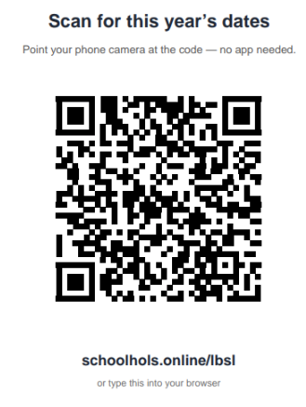

We think this is an absolutely wonderful tool and would appreciate any feedback you may have!

Autumn 1 Sports Events and Intents:

22/09 Girls’ football Year 5 and 6: To develop confidence, teamwork and football skills whilst encouraging girls to enjoy participating in competitive sport.

24/09 Traditional Sports Day Year 3 and 4: To develop physical and social skills through participating in a range of engaging, accessible and inclusive activities.

28/09 Kids Cup Football Year 5 and 6: To work successfully as a team to achieve a common goal within a competitive environment, developing teamwork, resilience and communication.

1/10 Cross-Country Year 5 and 6: To develop stamina, determination and resilience whilst challenging themselves to perform to the best of their ability.

9/11 League A Football Year 5 and 6: To develop teamwork, communication and tactical skills whilst competing together to achieve a common goal.

16/11 League A Football Year 5 and 6: To develop valuable physical, social and communication skills through working as a team to achieve a common goal.

Attendance
Learning days lost to term-time holidays so far this year: 24
Holidays during school time can only be authorised in exceptional circumstances and time off school is lost learning time. Please do not book holidays during school term time. For our term dates, please see the school website or the calendar below. https://www.langho-st-leonards.lancs.sch.uk/page/?title=Term+Dates&pid=132

Medical Appointments
Please ensure that medical appointments (including dental appointments) during school hours are kept to a minimum and we ask that these are scheduled outside of school hours wherever possible. Every lesson missed is a missed learning opportunity.
Please also note that our office staff are extremely busy. If there is an unavoidable medical appointment for which your child(ren) will need to be collected early, please let the office staff know in the morning. If you turn up unexpectedly to collect your child(ren) there will be a wait.

 | 14th-18th September
1st | Swifts | 100% - Well done!!!
2nd | Blackbirds | 99.11%
3rd | Falcons | 98.62%


Primary School Admissions
Primary school admissions for 2027 Reception starters are open.
(Closing date: 15th January 2027)
If you, or someone you know are looking for a reception place for September 2027, we would be delighted to show you our wonderful school.

St. Leonard’s Open Evening
Thursday 22nd October 2026
5:30-7:00pm

Daytime ‘School in Action’ Tours
(Please contact the school office to book
01254 247156 info@langho-st-leonards.lancs.sch.uk)
Wednesday 4th November
Tuesday 10th November
Thursday 19th November
Monday 23rd November
Wednesday 2nd December

Please see our school website for more admissions details: https://www.langho-st-leonards.lancs.sch.uk/page/?title=Admissions&pid=38

Lancashire County Council admissions website: https://www.lancashire.gov.uk/schools-and-education/school-admissions/starting-primary-school/
Secondary School Admissions

Secondary school admissions are open. The closing date is 31st October 2026.

https://www.lancashire.gov.uk/schools-and-education/school-admissions/starting-secondary-school/
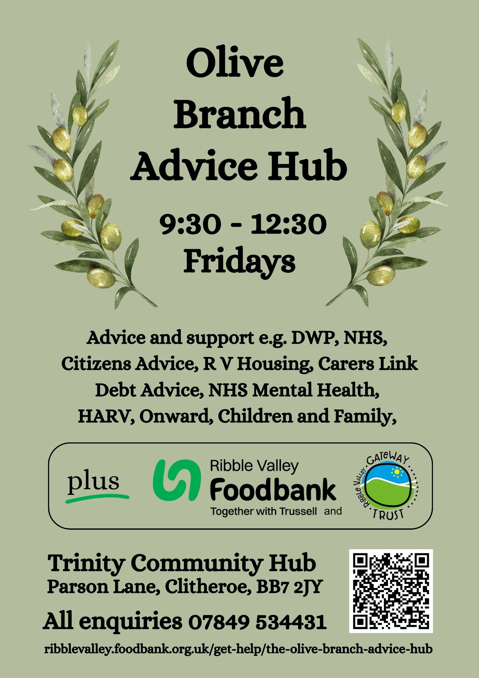

Below please find the link to Ribble Valley Foodbank.
https://ribblevalley.foodbank.org.uk/get-help/
Ribble Valley Foodbank is open on Fridays between 09:30 and 12:30 at Trinity Methodist Church and Community Hub, Parson Lane, Clitheroe, BB7 2JY.
The Olive Branch Advice Hub is also open at the same time, providing free, confidential advice and support.
Please note that you will need a voucher code to collect a food parcel - use the ‘Get help’ tab to find out more about getting both food parcels and free advice.

REMINDERS
Labelled Items
We have already found a huge number of unnamed / unlabelled items of clothing. Please ensure that ALL of your child’s items (coats, jumpers, lunchboxes, water bottles, bookbags) are clearly labelled with your child’s name. (A mark or item that only your child can identify is not sufficient.)
Labelled items are returned to children. Unlabelled items are left in lost property, available to check in the friendship area after-school. However, if these are not claimed in a timely manner, they will be made available on the rail in the office entrance area.
For further details, please see our uniform policy available on our website:
https://www.langho-st-leonards.lancs.sch.uk/page/?title=School+Uniform&pid=136

ACHIEVEMENTS OUTSIDE OF SCHOOL

Congratulations Arthur who came first in his class at a show jumping competition this past weekend!
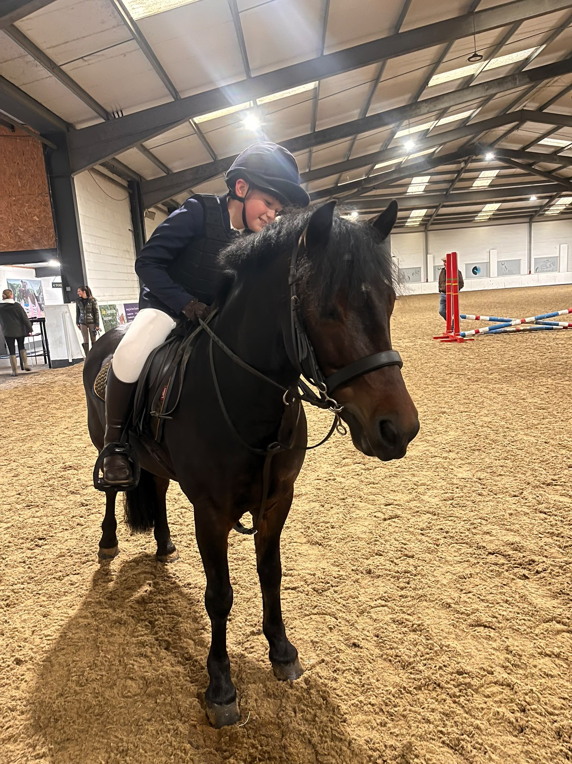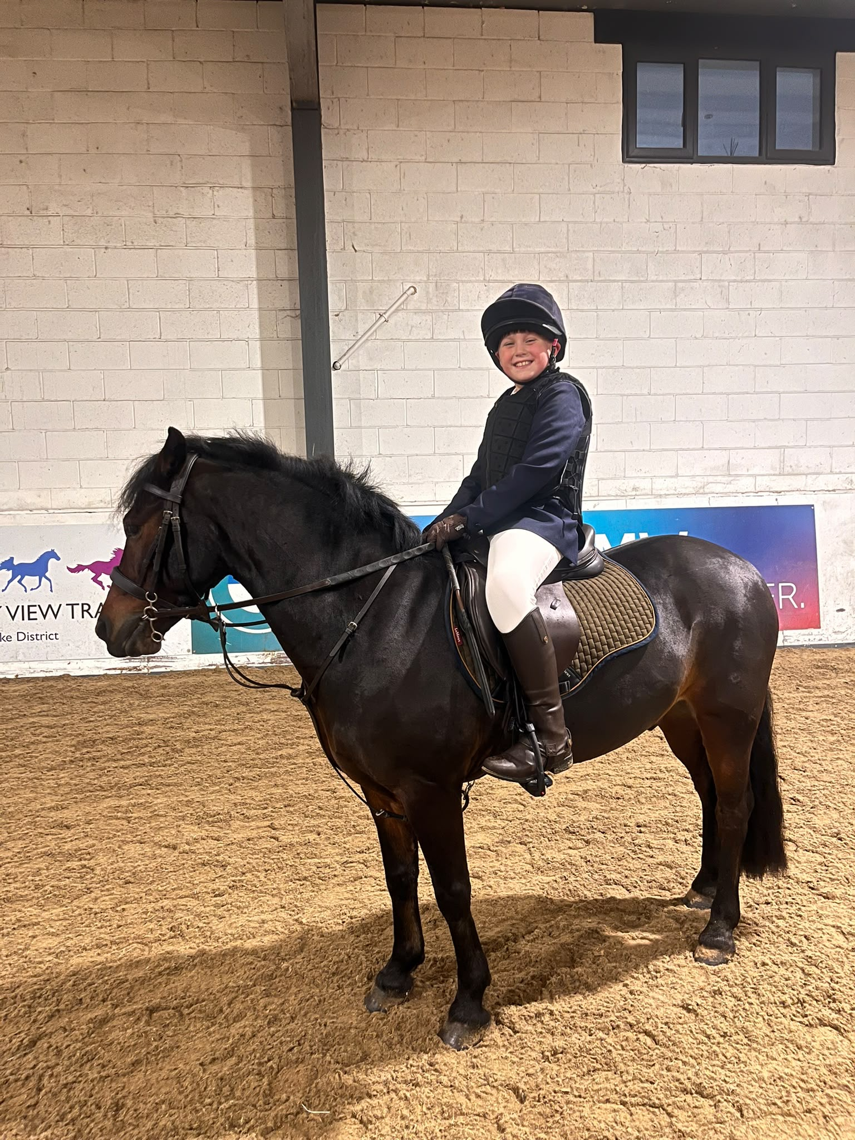
DIARY DATES
Autumn 1 - 2026
Mon 28th Sep | 6:00pm - Booking opens for Parents’ Evening (booking via Arbor)
Fri 2nd Oct | Harvest Festival donations - Cupboard food or a money donation in an envelope - donations to be distributed by church.
Sun 4th Oct | 10:30am - Harvest Festival Family Service at St. Leonard’s Church
Tue 6th Oct | 2:00-3:00pm Preschool Stay and Play - please contact the school office to book
Tue 6th Oct | 3:30pm-4:15pm Y1-Y6 ‘Show and Share’ Parents/Carers are invited into class after school to look at your child’s books with them. No booking necessary.
Wed 7th Oct | 9:00am - Robins class-led worship in St. Leonard’s church
Thu 8th Oct | 2:00-3:00pm Preschool Stay and Play - please contact the school office to book
Mon 12th Oct | Individual and Siblings Photos (non- St. Leonard’s siblings from 8:30)
Thu 15th Oct | Reception -Y6 Parents’ Evening - booking will open on Monday 28th September 6:00pm
Fri 16th Oct | St. Leonard’s Day - Non-uniform day in exchange for chocolate / £2 donation (Going towards church family fun day 17th October)
Sat 17th Oct | Family Fun Day at St. Leonard’s Church - More information to follow
Wed 21st Oct | Flu Vaccines - More details to follow
Thu 22nd Oct | 9:00am - Wrens class-led worship in St. Leonard’s church
Thu 22nd Oct | 5:30pm-7:00pm Reception 2027 Starters’ Open Evening
Fri 23rd Oct | 2:45pm - Reception Class Concert - School Hall
Fri 23rd Oct | 3:30pm - School closes for half-term
Autumn 2 - 2026
Mon 2nd Nov | 8:40am - School re-opens for children after half-term
Wed 4th Nov | Reception 2027 Starters ‘School In Action’ Tour - please contact the school office to book (01254 247156)
Tue 10th Nov | Reception 2027 Starters ‘School In Action’ Tour - please contact the school office to book (01254 247156)
Thu 19th Nov | Reception 2027 Starters ‘School In Action’ Tour - please contact the school office to book (01254 247156)
Mon 23 Nov | Reception 2027 Starters ‘School In Action’ Tour - please contact the school office to book (01254 247156)
Wed 2nd Dec | Reception 2027 Starters ‘School In Action’ Tour - please contact the school office to book (01254 247156)
Fri 18th Dec | 1:30pm - School closes for all children for Christmas holidays

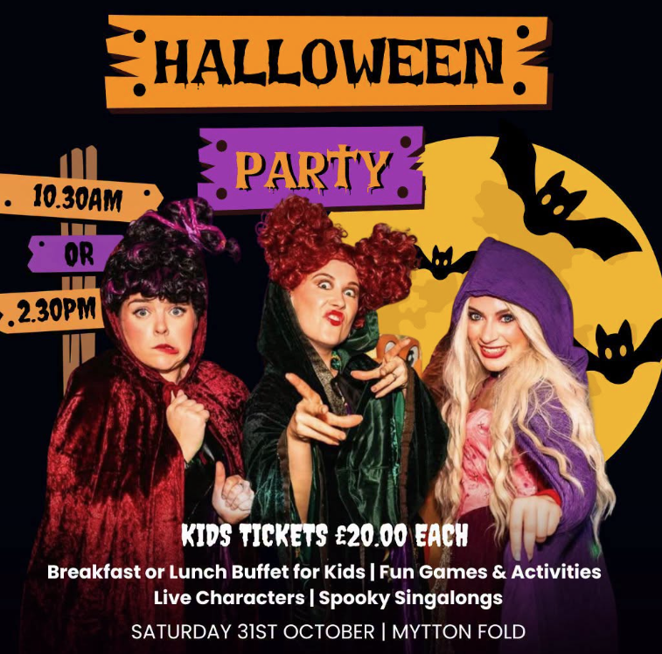

Join us this Halloween, for some family-friendly fun, featuring the team from @happilyeverafterprincesses with some added Hocus Pocus magic

Choose from a morning or afternoon session for just £20 per child and enjoy:

 Kids Breakfast or Lunch Buffet, plus jugs of cordial
 90 minutes of magical entertainment with live Hocus Pocus characters
 Spooky singalongs
 Wicked Halloween games

Costumes are highly encouraged, so dress to impress and get ready for a frightfully fun Halloween! 

*Adults tickets are £5.00 and include tea and coffee on arrival.
Pre-book your tickets for both sittings now: https://bit.ly/4w63F1m

They can be booked directly on ticketsource here: https://www.ticketsource.com/mytton-fold-hotel

