Friday 30th January 2026

Dear Parents and Carers,

It is with sadness but a huge amount of pride that I am writing to share the important news that after fourteen years of dedicated service, Mrs Amanda Cronshaw is leaving St Leonard’s having secured her first headship post at Sabden Primary School!
This appointment is an exceptional achievement and one that we are immensely proud of. While we are of course disappointed to be losing such a valued and well-respected member of our staff team, this is very much a moment for celebration.
During her time here, Mrs Cronshaw has progressed from being a member of support staff, to qualifying as a teacher, to taking up SENCo responsibilities and leading Key Stage 2, then eventually becoming Assistant Headteacher.
She has consistently demonstrated the drive and determination needed to continually develop as a leader in school and contributed significantly to our school improvement journey, particularly during the past five years when I have had the privilege to work alongside her.
The hard work, professionalism and commitment from Mrs Cronshaw has had a huge impact on the lives and future outcomes of hundreds of children and her legacy will be felt for a long time to come.
Mrs Cronshaw will take up her new post after the Easter holidays. I have written separately to Wrens parents with carefully planned arrangements for the teaching of Year 6 in the Summer term, and during this time, I will fulfil SENCo responsibilities across school.
On behalf of the Governing Body, I am sure you will join me in wishing Mrs Cronshaw the very best of luck as she embarks upon her next chapter, positively influencing the lives of the children and families within the Sabden community.

Yours Sincerely,
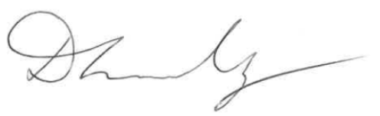

Mrs Dawn Lindley

