Friday 30th January 2026

Dear Y6 Parents and Carers,
Following my letter to announce Mrs Cronshaw’s appointment as Headteacher of Sabden Primary School from 13th April 2026, (the start of the Summer term), I am writing to inform you of the arrangements we have made to ensure that our Year 6 children continue to be taught well, prepared for SATs assessments, and are secondary school ready by the time they leave us in July.
From next week, Mrs Carney (Deputy Headteacher) and myself will be working closely with and teach alongside Mrs Cronshaw, to ensure we both gain a thorough knowledge and understanding of each child’s learning needs and develop a closer relationship with each child. This will develop children’s confidence and support a smooth transition for the Summer term when Mrs Cronshaw leaves.
After Easter, Mrs Carney and myself will take full responsibility for the teaching of Reading, English Grammar, Punctuation and Spelling, Writing and Maths. The rest of the curriculum will be shared between ourselves and Mrs Murphy, who already teaches in Year 6 on Fridays. Mrs Esson will continue to be a consistent presence in Year 6, providing both learning and pastoral support.
Parents evening is being held the week after February half term. Should you need to discuss anything prior to this, please let the school office know and we will be in touch. For those parents with children with additional needs, Mrs Cronshaw and myself would like to offer a separate meeting at some point before Easter to discuss further details and strategies that may help those children to successfully manage this change.
Mrs Cronshaw and I have spoken to all Year 6 children this afternoon to help them understand that we have got them all in safe and consistent hands. I hope this plan goes a long way to alleviating any worries or concerns that you may have about the timing of this upcoming change.
Thank you for your support as always, it is very much appreciated,
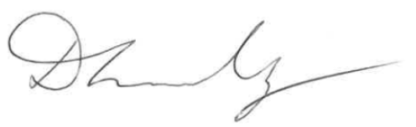
Mrs Dawn Lindley

