
Langho and Billington St Leonard's C of E Primary School Early Years Foundation Stage (Little Lennie’s) – Fantastic Five!

Little Lennie’s  Autumn | 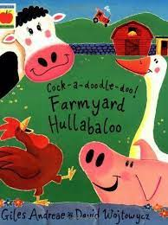  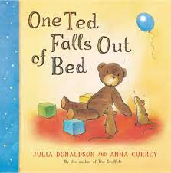  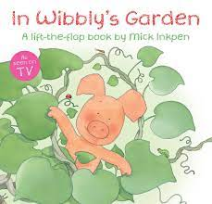  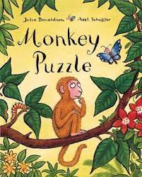  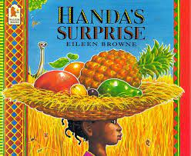 | Titles  In Wibbly’s garden  Handa’s Surprise  One Ted falls out of Bed  Monkey Puzzle  Farmyard Hullabaloo
Little Lennie’s  Spring | 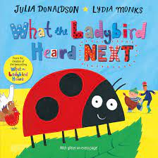  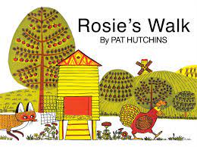  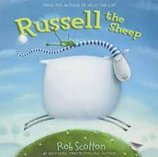  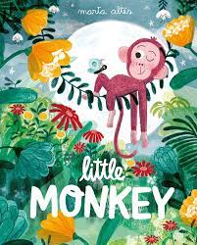  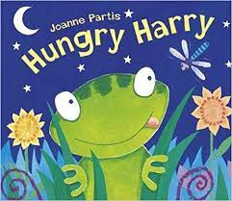 | Titles  Russell the sheep  Hungry Harry  What the Ladybird heard next  Little Monkey  Rosie’s Walk
Little Lennie’s  Summer | 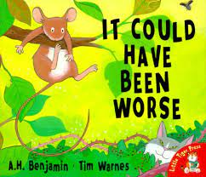  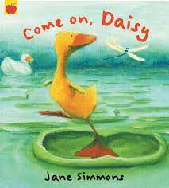  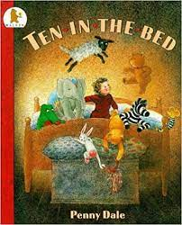  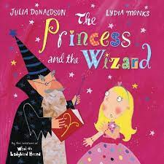  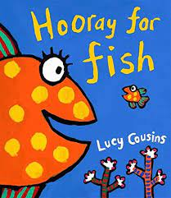 | Titles  Come on, Daisy!  Hooray for Fish!  It could have been worse,,,  The Princess and the Wizard  Ten in the Bed

